**Washington TWP Food Service Welcome Page**

#### 

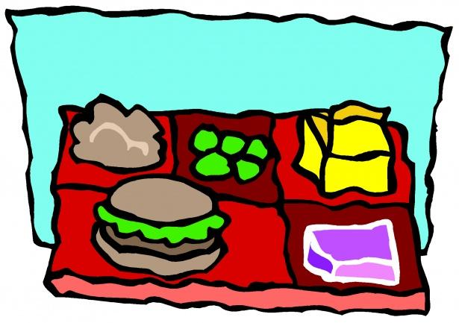

The Washington TWP Food Service Department welcomes you back to another year of learning and meeting new friends. There are so many fun activities, clubs and sports to get involved with in our schools; make sure you give something new a try, including something that you may have never tried from our cafeteria.

We have over 50 staff members that are so excited to welcome you back through the lunch line. Some of our new items include: Buffalo Walking Taco, Breakfast Pizza, Bacon Chicken Ranch Flatbread, Honey Peanut Butter & Jelly and Raspberry Peanut Butter & Jelly. Of course we are still offering the #1 and #2 favorites, Chicken & Waffles and General’s Chicken. Give lunch a try. We will be serving breakfast and lunch on the first day of school. Look for the new breakfast cart in the Core of the High School for more of a grab & go style meal service. Our menus are posted on our website.

The 2025-2026 School Meals and Summer EBT Application is available on our website. You may apply for free/reduced meals on [Payschoolscentral.com](http://payschoolscentral.com) or bring in your paper application to our office at 118 Chapel Heights RD near the buses.

We will be updating our website throughout the year so please come back and take a look. If you ever have any questions, please contact me at the number below. I look forward to serving delicious and nutritious meals to everyone.

Jennifer M. Mullin, SNS

856-582-4010

jmullin@wtps.org

# 

# Celebrating Wellness Week 2025

|  |  |  |
| --- | --- | --- |
|  |  |  |
|  |  |  |

## “

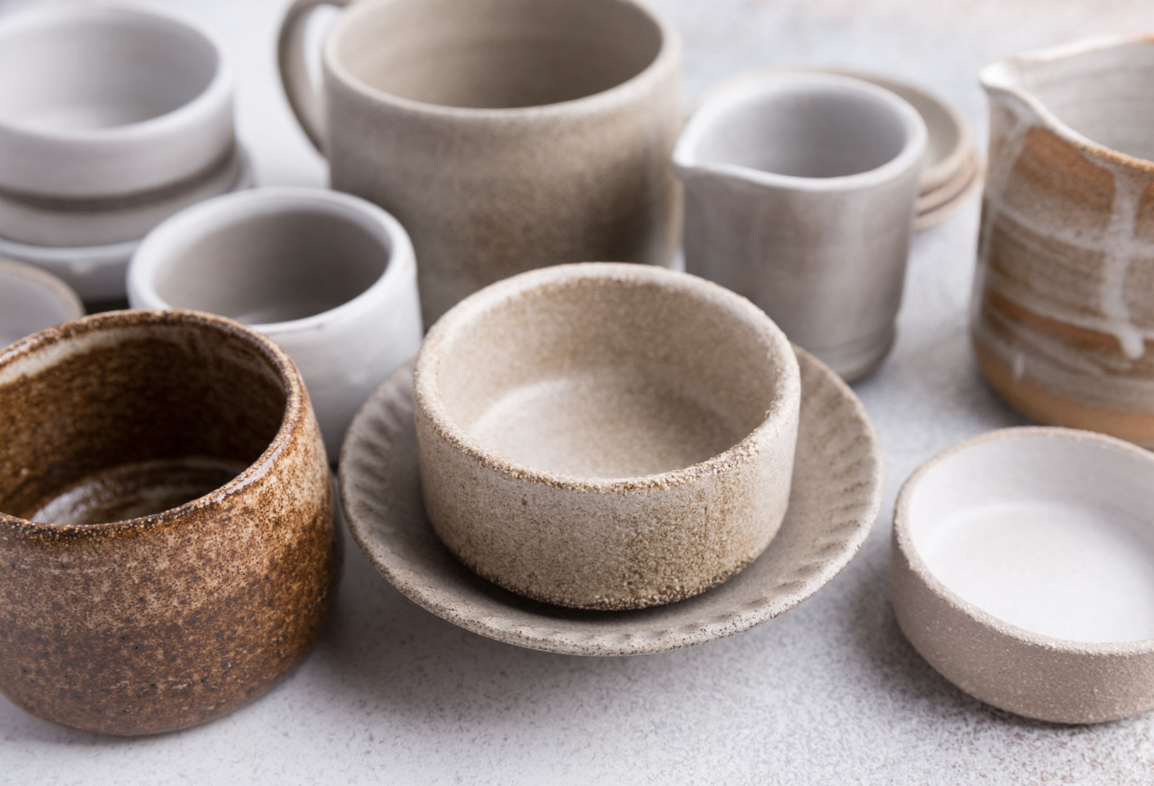

Currently available at the studio. Photo credit: Person

# Our products

Every piece tells a story. From the moment the clay is wedged to the final glaze firing, each step in the process is undertaken with meticulous care. Our team of skilled artisans and dedicated apprentices work together to create unique pieces that reflect the beauty of handmade craftsmanship.

What we offer:

* Artisanal tableware: Elevate your dining experience with our collection of elegant plates, bowls, mugs, and serveware
* Home decor: Discover a curated selection of vases, planters, and decorative pieces that enrich your home with warmth and character
* Bespoke creations: Let us bring your vision to life with a commissioned piece made just for you

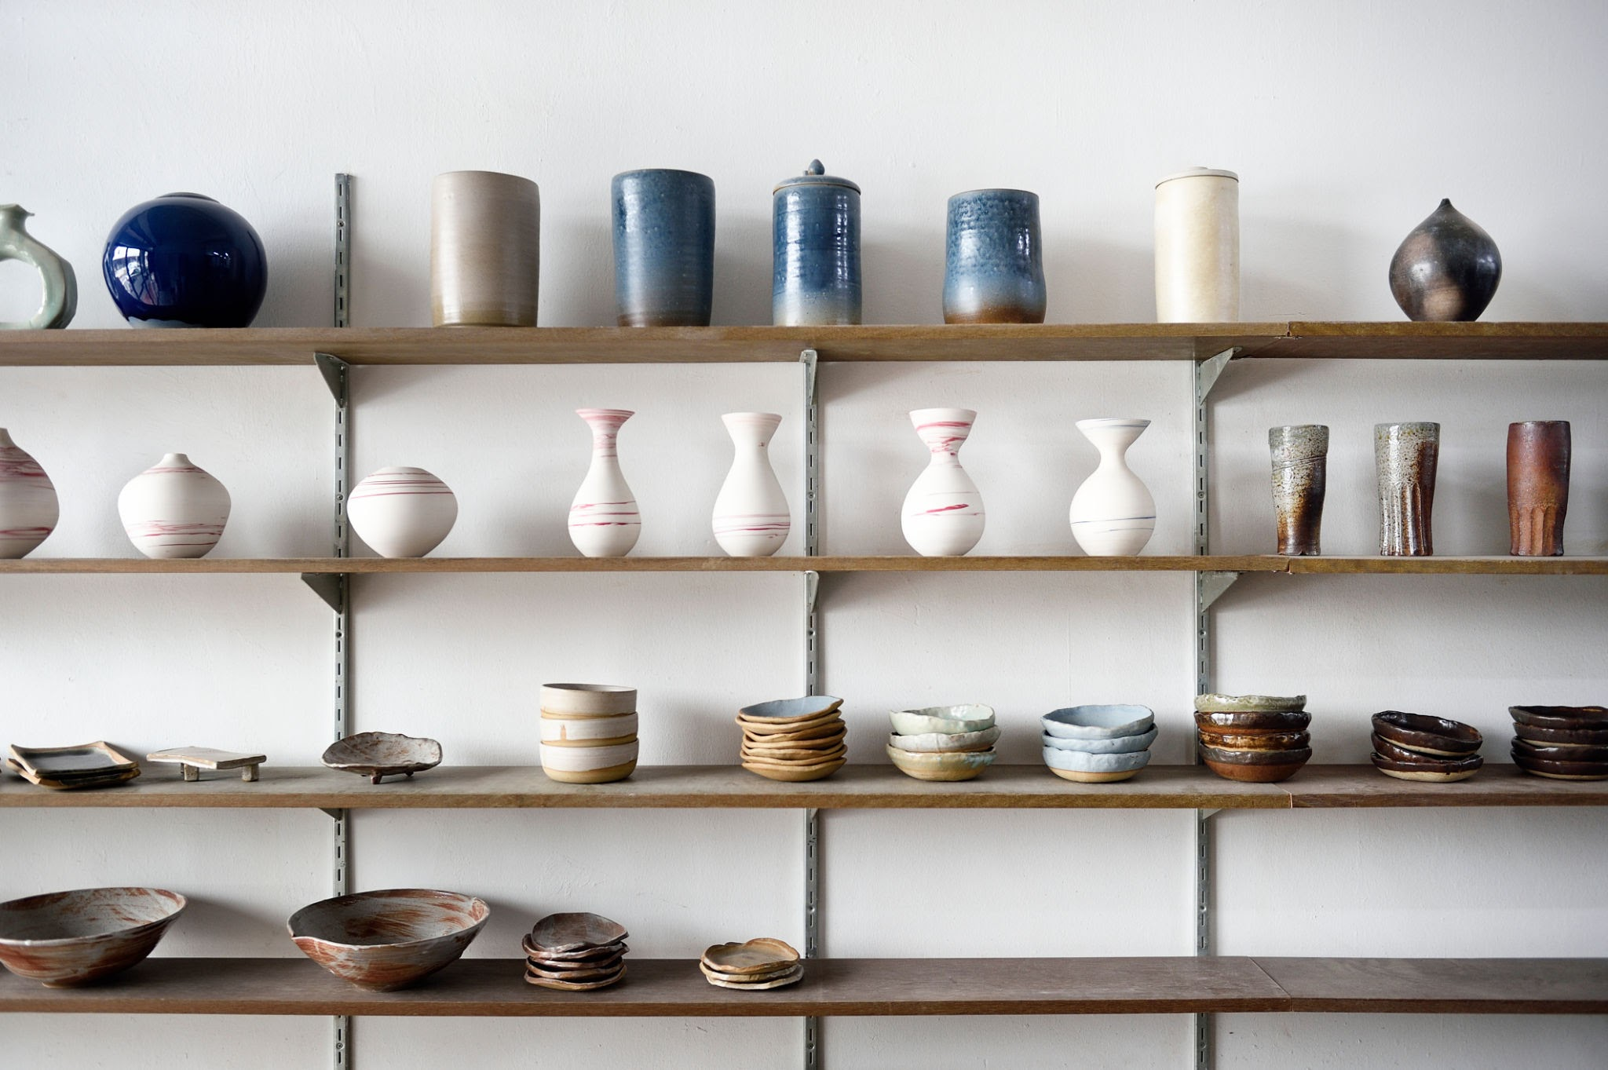

Goods for the home, by our artisans. Photo credit: Person

# Community and craft

At Pottery Place, we believe in the power of art to bring people together. That might mean finding the perfect piece to complete your family home, or connecting with classmates while creating your own masterpieces.

We currently offer three classes in the studio to help you experience the joy and community of ceramics.

### Introduction to hand-building

Learn the basics of hand-building in a fun, supportive environment.

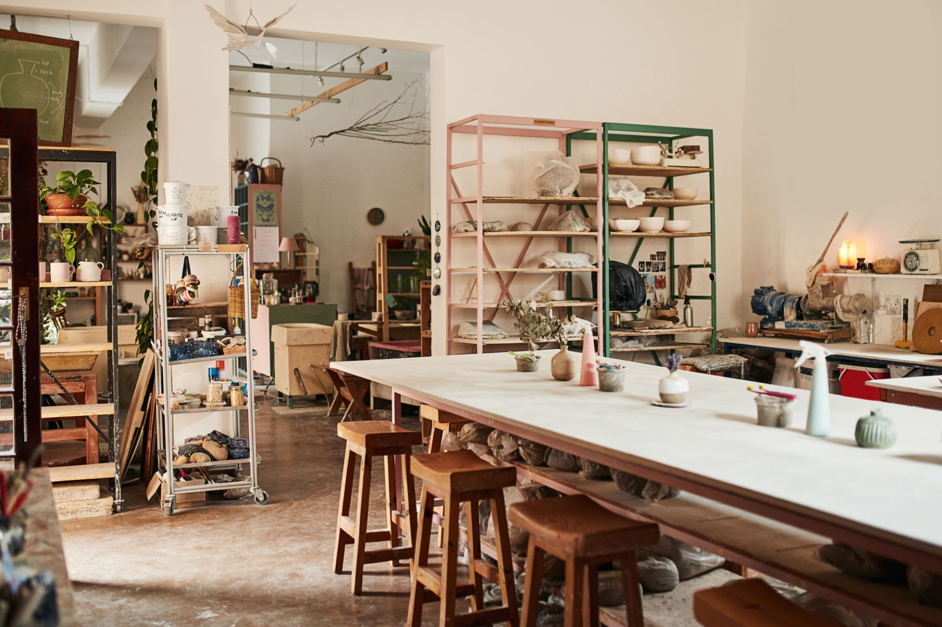

### Wheel-throwing for beginners

Get comfortable on the wheel with this introductory class, no experience necessary.

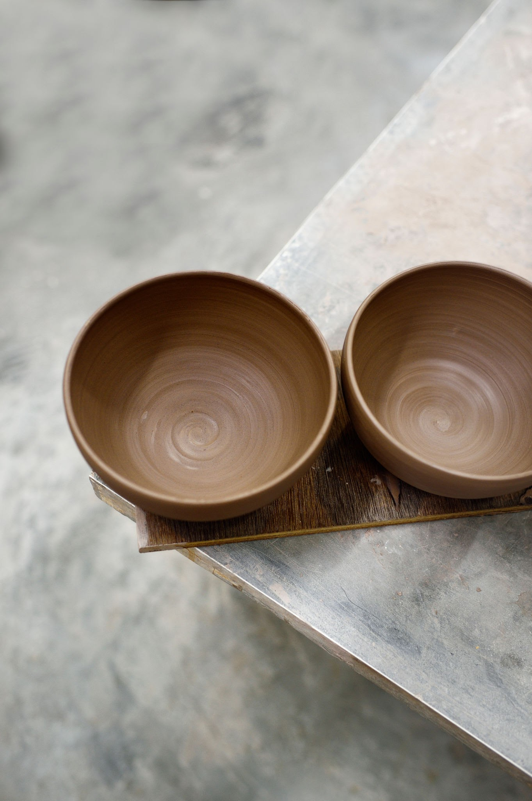

### Intermediate wheel

Improve your wheel-throwing skills and try more advanced projects in this intermediate class. You must complete Wheel 1 before enrolling.

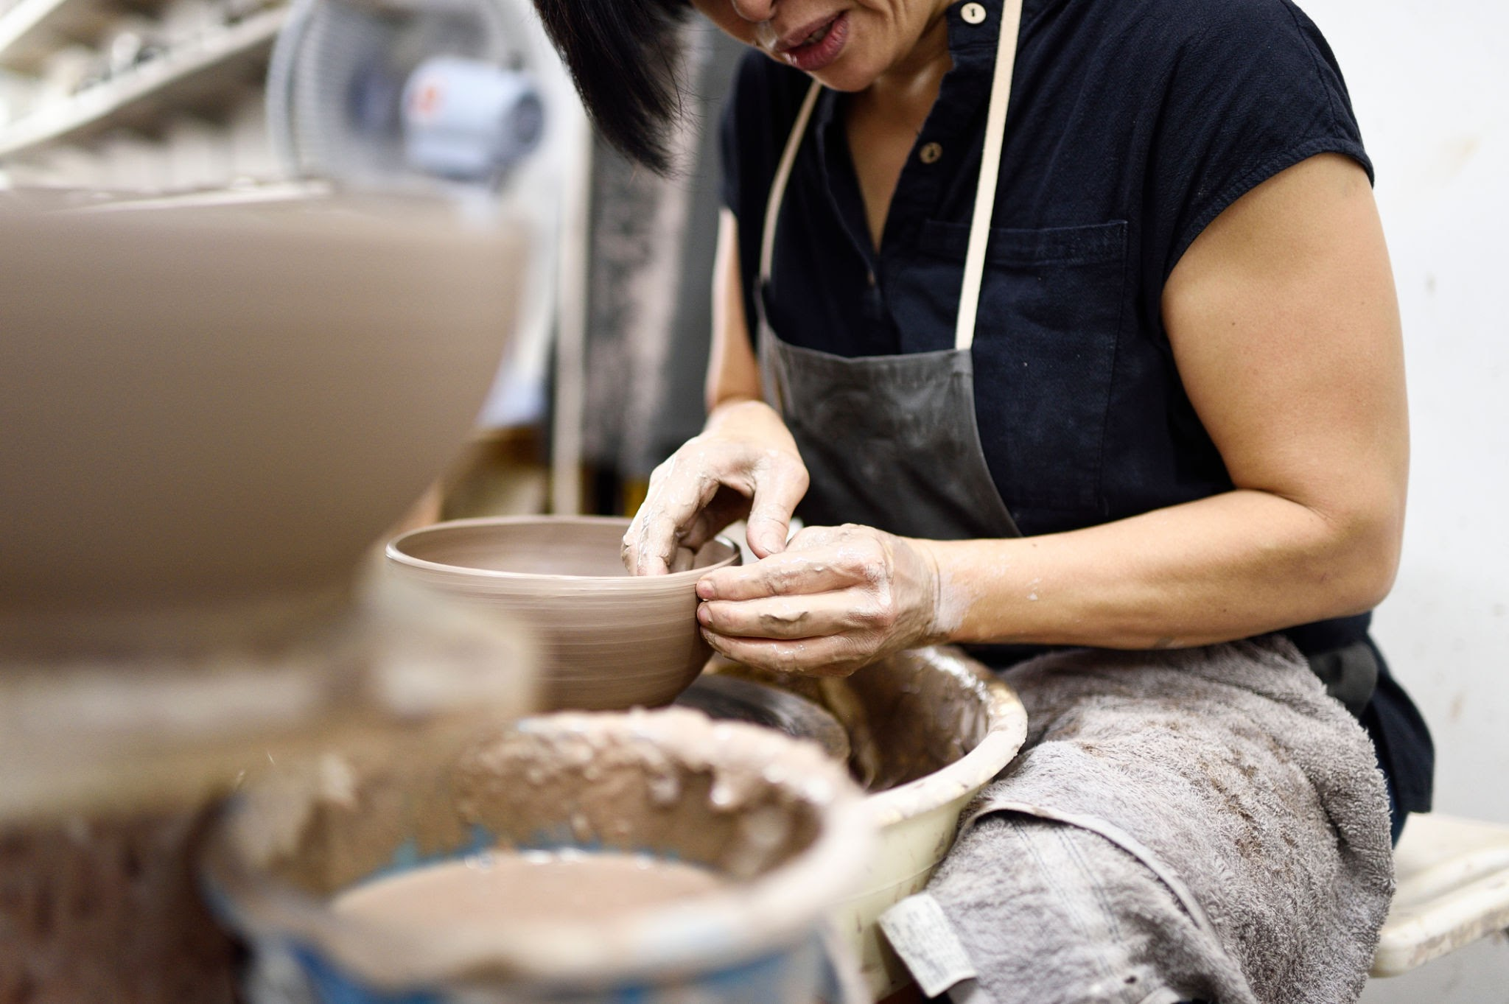

We invite you to join our growing community of ceramic enthusiasts. Visit our studio, attend a workshop, or explore our collection online. Follow us on social media to stay updated on our latest creations, upcoming events, and special promotions.

Thank you for being a part of our story. Let's create something beautiful together. Learn more

# Share & follow

### For any inquiries, please contact:

Person

Email

Website

YouTube